FWS-620
4.5” Outdoor Waterproof Wall Mount Speaker (2.5W/5W/10W/20W)
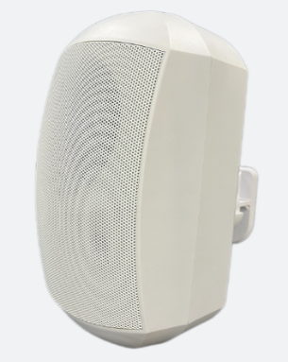
Feature:
- Commercial PA system wall mount speaker with transformer
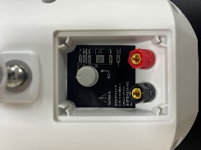
- Waterproof wall mount speaker of outdoor used
- Ideal for SPA, washroom, shower room and clean room background music system
- Rated power output 2.5W/5W/10W/20W at 100V&8ohms
- 4.5” woofer and 0.75” tweeter
- Waterproof rate of IP65 for outdoor used
- Line input 100V,70V&8ohms
- ABS enclosure and metal grille in white and black color
- Quick installation by 360 degree bracket

Specification:
Model | FWS-620
Description | 4.5” Weatherproof Wall Mount Speaker
Rated Power Output | 2.5W/5W/10W/20W
Line Input | 100V ,70V&8ohms
Frequency Response | 120-15KHz
SPL(@1W/m) | 86dB（1W/1M）
Speaker Unit | 4.5”*1 woofer, 0.75”*1 tweeter
IP Rate | Waterproof IP65
Dimension | 141(W)×138(D)×243(H)mm
Material | ABS enclosure and Metal grille in black
Mounting Way | 360 degree install wall mount bracket
Weight | 1.95KG
Packing | 470*420*375 4PCS/Carton
Frequency Response & SPL Diagrams
